Asia-China-Coin-Song, S-Jing Ding Period, 1260-1264, 錢牌Qian Pai (Coin Tallies), Qián Fàn, 钱范 (money cast), H 17.903

Southern Song, Jing Ding Period, 1260-1264, 錢牌Qiαn Pai (Coin Tallies) in a Qián Fàn, 钱范 (money cast),

Qian Pai (coin taillies) are attributed to the time of the late Southern Song，probably the Jing Ding period (1260-1264). A contemporary source says: “The court ministries produced lead tablets for conven­ience of use in Hangzhou city because coins were not circulating." They were a desper­ate emergency economic measure. Lead and bronze specimens are known; the top of the tally can be square, rounded, or with cut-off corners. The省sheng (reduced) in their inscription refers to the Song “reduced hundred" system, whereby a nominal hundred cash was discounted by some 30 percent. Thus in the market place 100 cash was in fact equivalent to 77 for official use. 75 for general trading，72 for fish，meat，and vegetables，74 for gold and silver，68 for gems，fans， slave girls and crickets and 56 for writings一each sort of commodity had its own discount to the hundred.

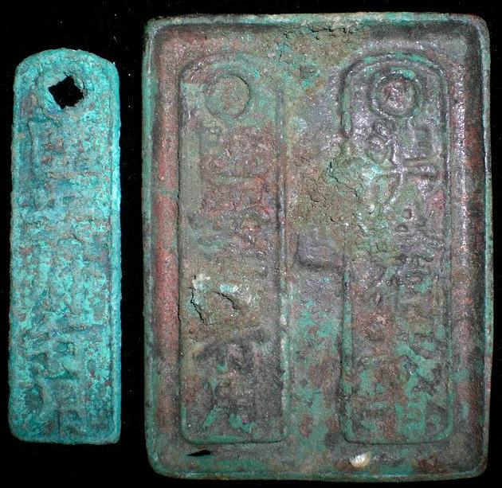

Qián Fàn, 钱范 (money cast), Rev:準(准)貳佰文省Zhun er bαi ωen sheng (Equal to 200 cash reduced). Rarity 1.

References: Fischer-Ding 1600, Schjöth 1064a, Hartill no. 17.903.

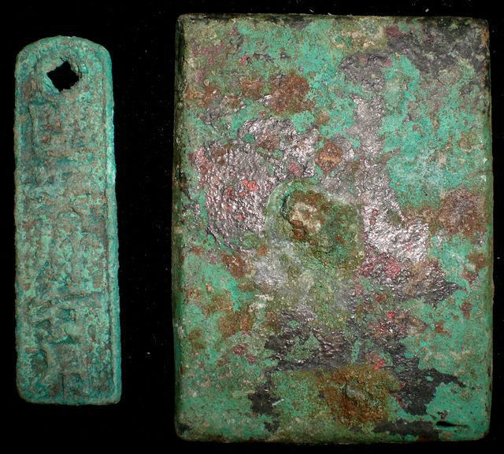

Qián Fàn, 钱范 (money cast), Obv: 準(准)貳佰文省Zhun er bαi ωen sheng (Equal to 200 cash reduced). Rarity 1.

